Use an SSH client to connect to the server. PuTTY is a great free one if you are using Windows. If you are using a mac, probably Terminal. You should have done this in DBA-120 so hopefully you will remember.

PuTTY.exe is posted in Moodle for you … there is no installation, simply drop it on to your desktop and start using it.

**Putty:**

-- Host Name: vweb-cit.abtech.edu

-- Port: 5937

-- **Save** the session with a name (if you want)

-- change the Window/Appearance to be a different font (if you want)

-- change the Window/Colours to system colours (if you you want)

-- return to the Session/Logging screen and make sure to click Save again to get all changes

-- either double click the Saved Session Name or select it and Open

-- click ‘Yes’ if asked about a “Potential Security Breach”

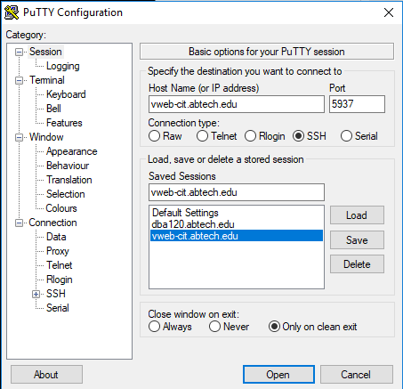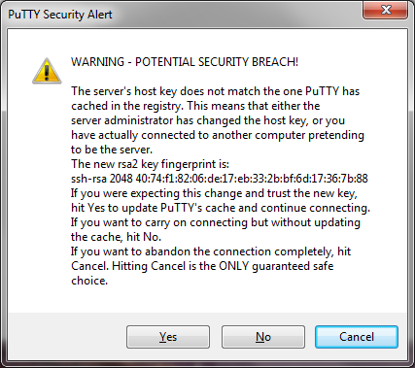

This is a new server and you are the maiden class ☺ The logon on information checks active directory and so you should be able to logon using your credentials that you use for Moodle/email.

Once you are connected, you will see the Linux prompt.

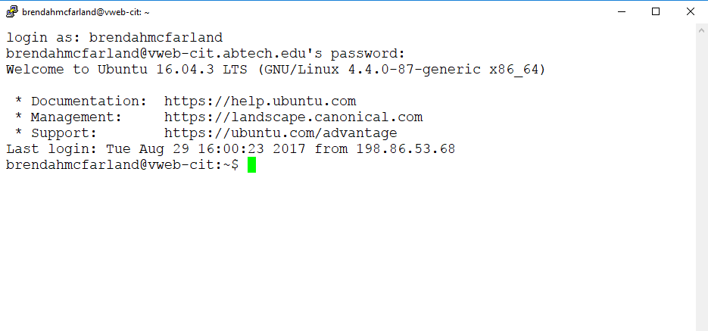

You will be in your home directory which is /home/dba210/userid

From here you will be able to logon to MySQL simply by typing the command mysql:

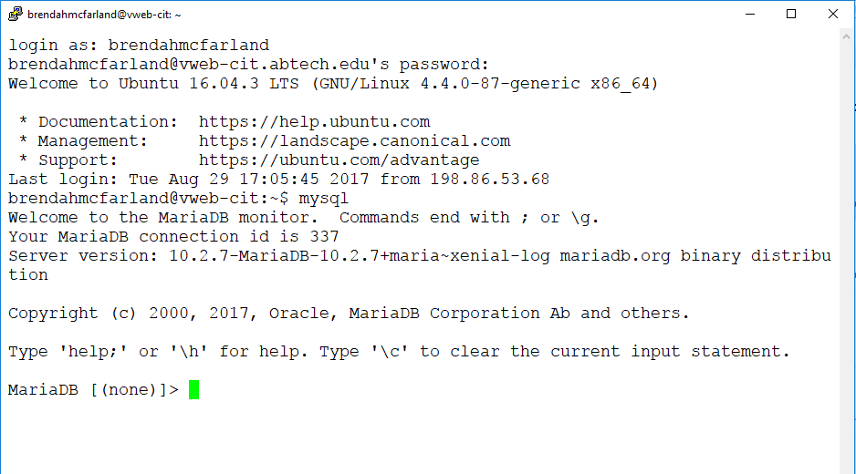

The MariaDB prompt means you are in MySQL.

Now that you are connected, let’s begin by doing some review work.

1. I have granted permissions for you to create a database call Projects_userid . SQL to create and populate this database can be found in Moodle in the “SQL for creating Projects_userid database folder. Be sure that you download the one that has your last name on it, as I have already edited them for you. You may open this in notepad++ or your editor of choice and see what tables, etc are being created and populated.
2. Once you have downloaded the file you need CreateProjectsDB_userid.sql from Moodle, you will need to move it to the server. You may use any SFTP client you wish. We use FileZilla in the classrooms here. It is free and easy to use …. You should have experience from DBA-120. You may download the client-side here <https://filezilla-project.org/> Use the same information to connect here that you used for PuTTY.
3. Once you have transferred the file over to the server, you should logon on the MySQL and run the “source” command with the complete filename to build your database.
4. In Moodle you will find a file to download called SQL Review with Projects DB.sql You will want to download that and open with an editor like notepad++. There are questions there to get you into writing SQL again. There are also instructions on how to complete the answers in this file. Once you have completed the worksheet, save it and upload to moodle in SQL Review submission.